**Aronimink Elementary School**

**2nd Grade Supplies List**

**2024-25 School Year**

2 HEAVY DUTY Plastic Folders (Red & Blue)

3 WIDE RULED Composition Books NO spirals, NO drawing area 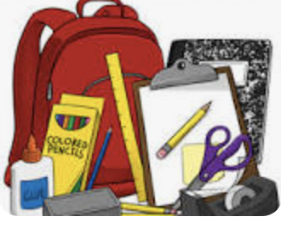

2 Glue STICKS

4 packs of SHARPENED TICONDEROGA Pencils

2 packs of 24 count Crayons

1 pair of kid scissors

1 pack of 4 EXPO markers

1 pack of 8-count markers

1 pack of colored pencils

1 highlighter

1 pack of post-it notes

1 wooden ruler with inches and centimeters

1 ZIPPERED Pencil Case (NO BOXES)

1 pack of eraser tops for pencils

1 pair of WIRED headphones NO EARBUDS

1 whiteboard with an eraser

2 rolls of paper towels

2 boxes of tissues

1 pack of baby wipes

1 pack of lysol/clorox wipes

1 pack of gallon ziplock bags

1 pack of sandwich ziplock bags

1 bottle liquid soap